IT 451. Hands-on exercises.
Class work/Homework 6.
- Learn how to invoke RMAN
To get to the RMAN we had to connect to it through the command line prompt of our operating system. We had to change the directory until we got to the BIN directory.

Screenshot of the RMAN directory from the BIN file of our database.
D:\app\Dana-2006\product\11.1.0\db_1\BIN>dir rman.exe

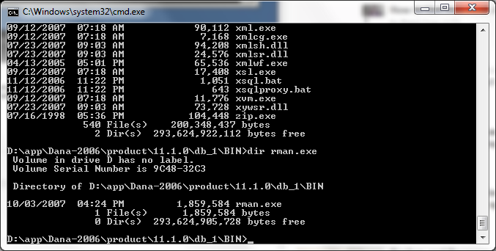

To open the recovery manager enter rman at the end of the statement.
D:\app\Dana-2006\product\11.1.0\db_1\BIN>rman
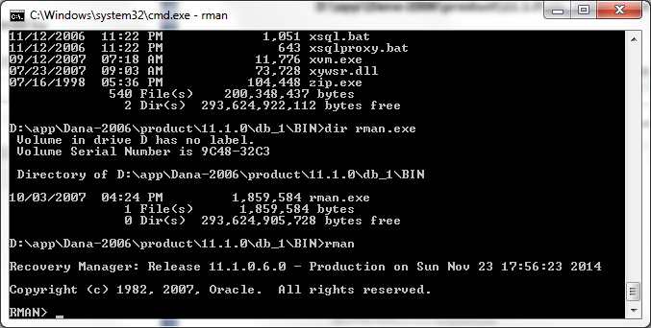
To open the recovery manager and connect it to our database we used:

D:\app\Dana-2006\product\11.1.0\db_1\BIN>rman target/

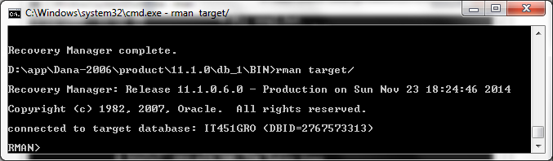

Configuring the RMAN backup settings in Enterprise Manager.

We left the default values in place here.
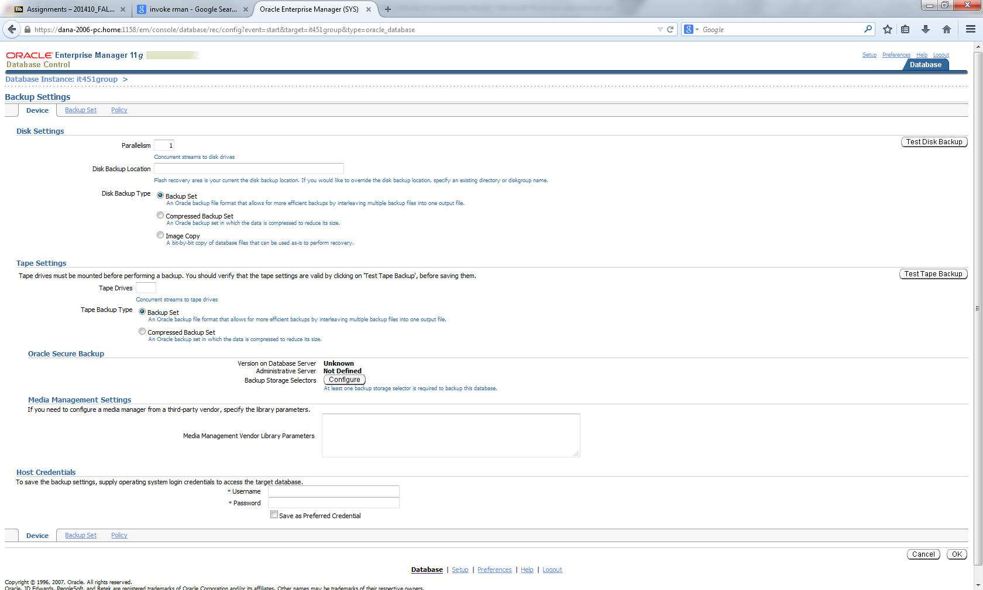

We made the maximum backup size 30GB.
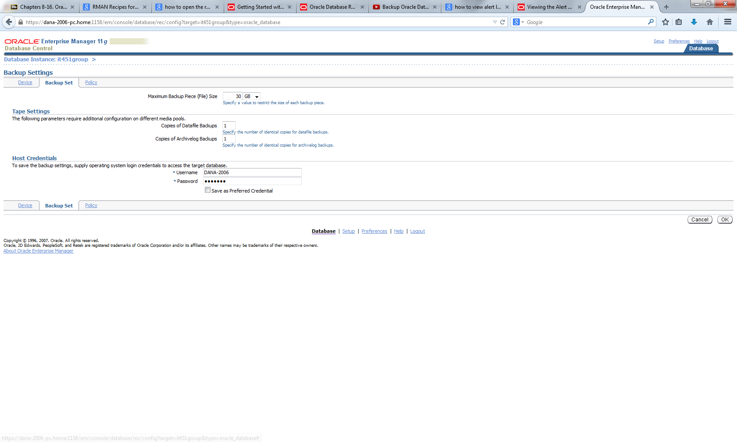
- Backup database

First we backed up the control file.

Pg867 used command:
RMAN>BACKUP CURRENT CONTROLFILE;
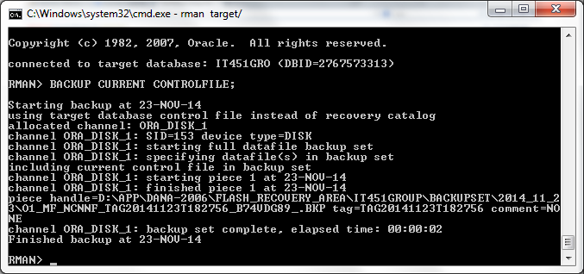

Backup using RMAN

We used the statement to do a full backup that is compressed.

Backup incremental level 0
As compressed backupset database;

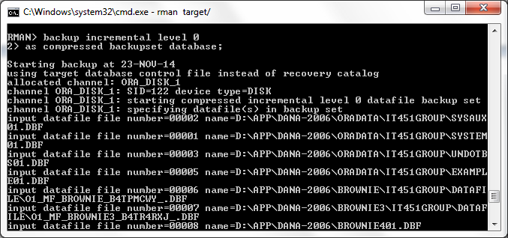

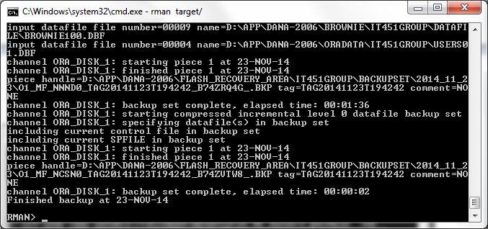

It backed up the files in the Flash Recovery Area directory
D:\app\Dana-2006\flash_recovery_area\IT451GROUP\BACKUPSET\2014_11_23

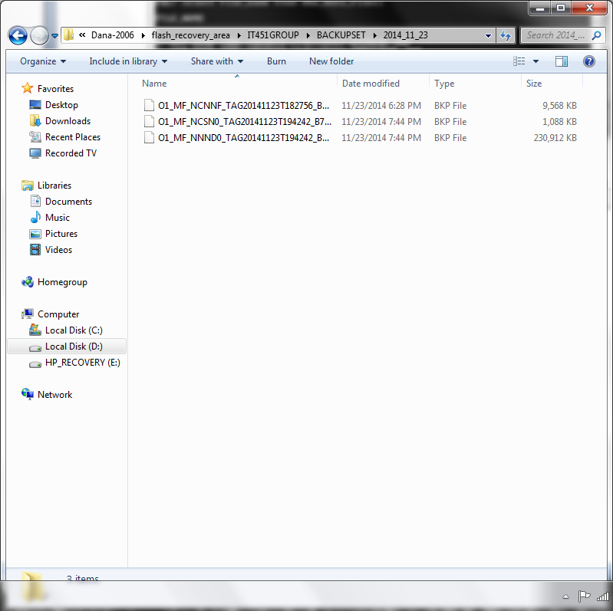

“cold backups”

We used the command
Select file_name from dba_data_files;
To show the files we have to back up.

Then we shut down the database.
Shutdown immediate;
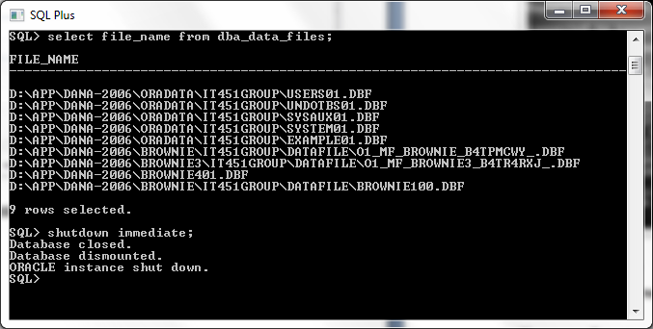

Then copy & paste the files we identified earlier using mouse and directories

We copied the files to the new path

C:\oracle backup

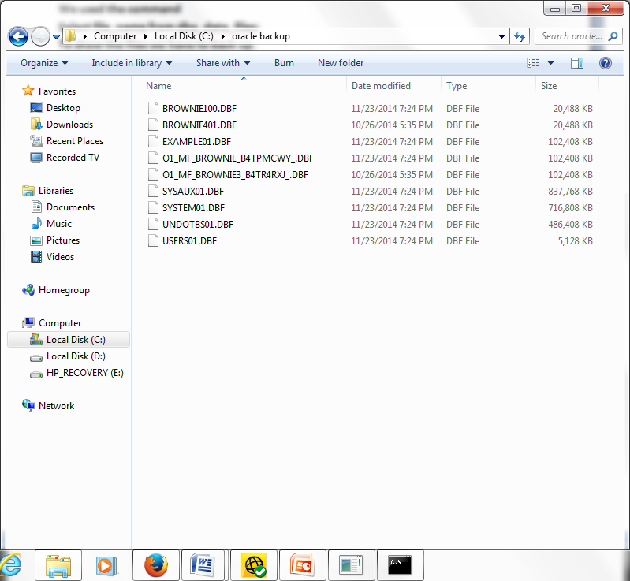

Then we brought the database back up

Startup open;

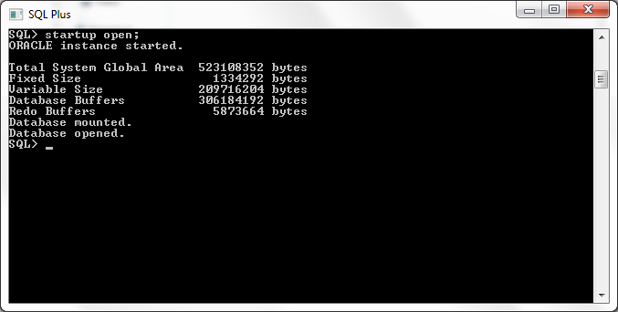
“hot backups”
Shutdown the database

Shutdown immediate;
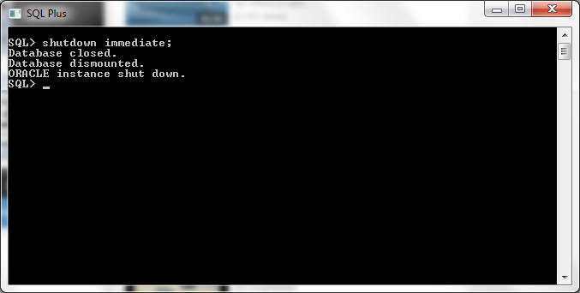
Db needs to be in archive mode:

After shutting down the database you startup mount the database so only we can access it.

Startup mount;

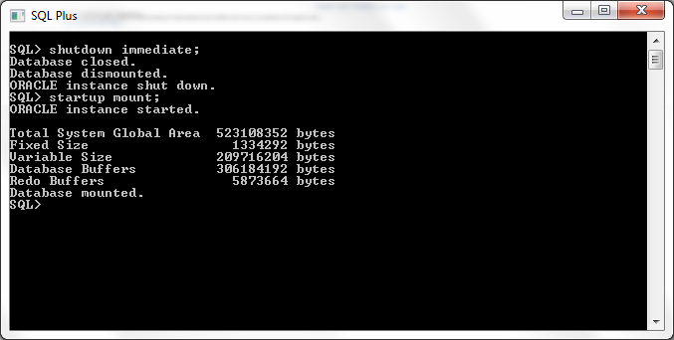

Then we turn on the archive log in the database

ALTER DATABASE ARCHIVELOG;

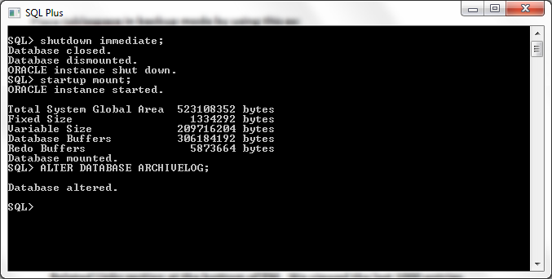

Then we open the database

ALTER DATABASE OPEN;

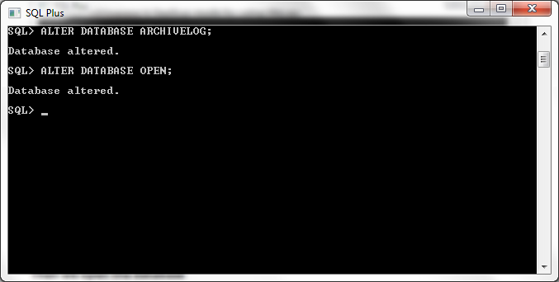

To check if archive log was enabled we used the statement:
Select log_mode from v$database;

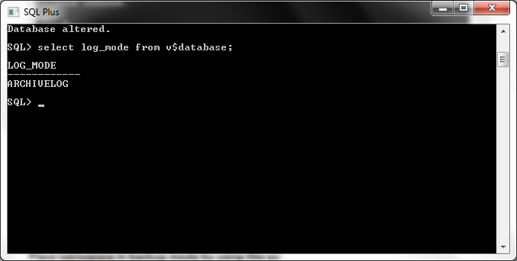

ALTER DATABASE BEGIN BACKUP; -- for a whole small DB

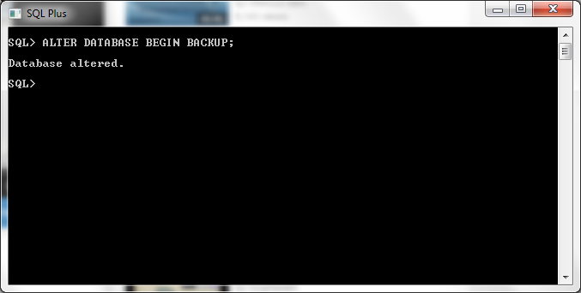

Then copy and paste the datafile to new location

Screenshot of the datafile in the original location.

D:\app\Dana-2006\Brownie\IT451GROUP\DATAFILE
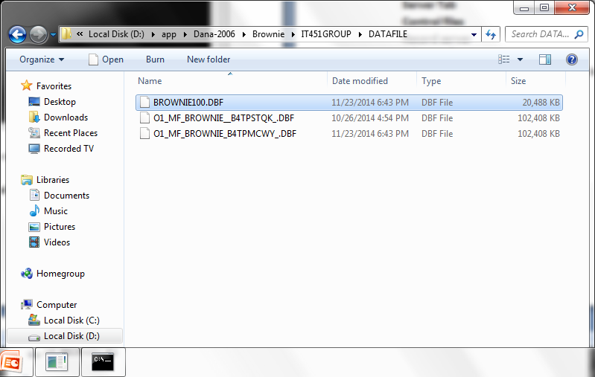

Screenshot of the new location

D:\app\Dana-2006\admin\it451group
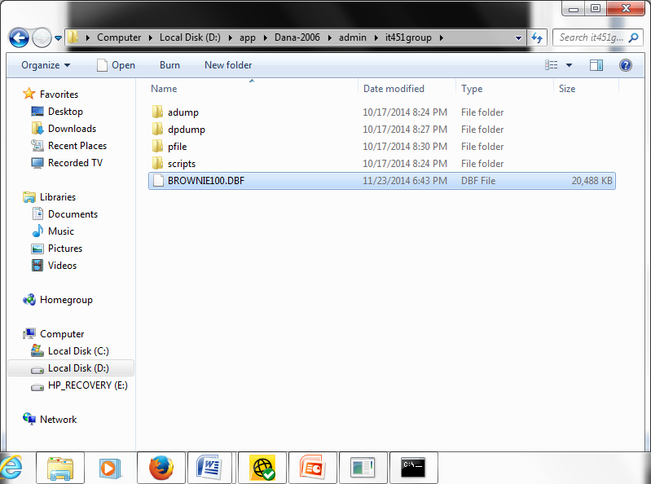
Then take the Database out of backup mode:
ALTER DATABASE END BACKUP;

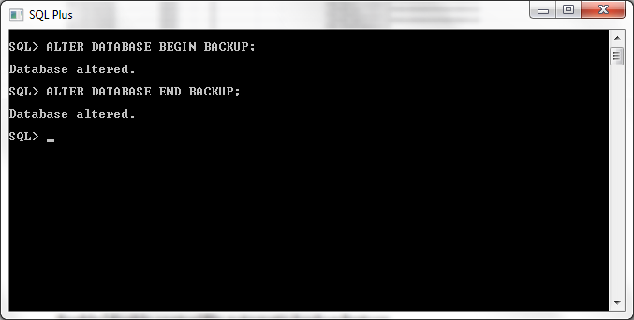

- Backup archive logs

We used RMAN to backup the archive logs.
Backup archivelog all;

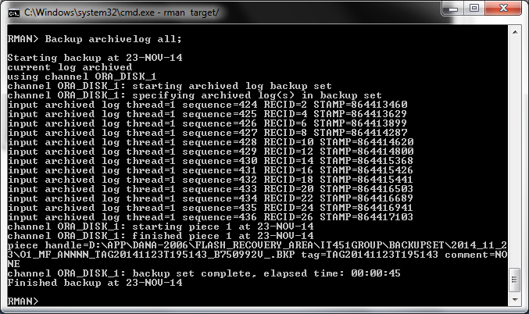

- Review alert log contents
To review the alert log contents, select the Alert Log Contents link from the Related Links section at the bottom of EM. We viewed the last 50 entries.

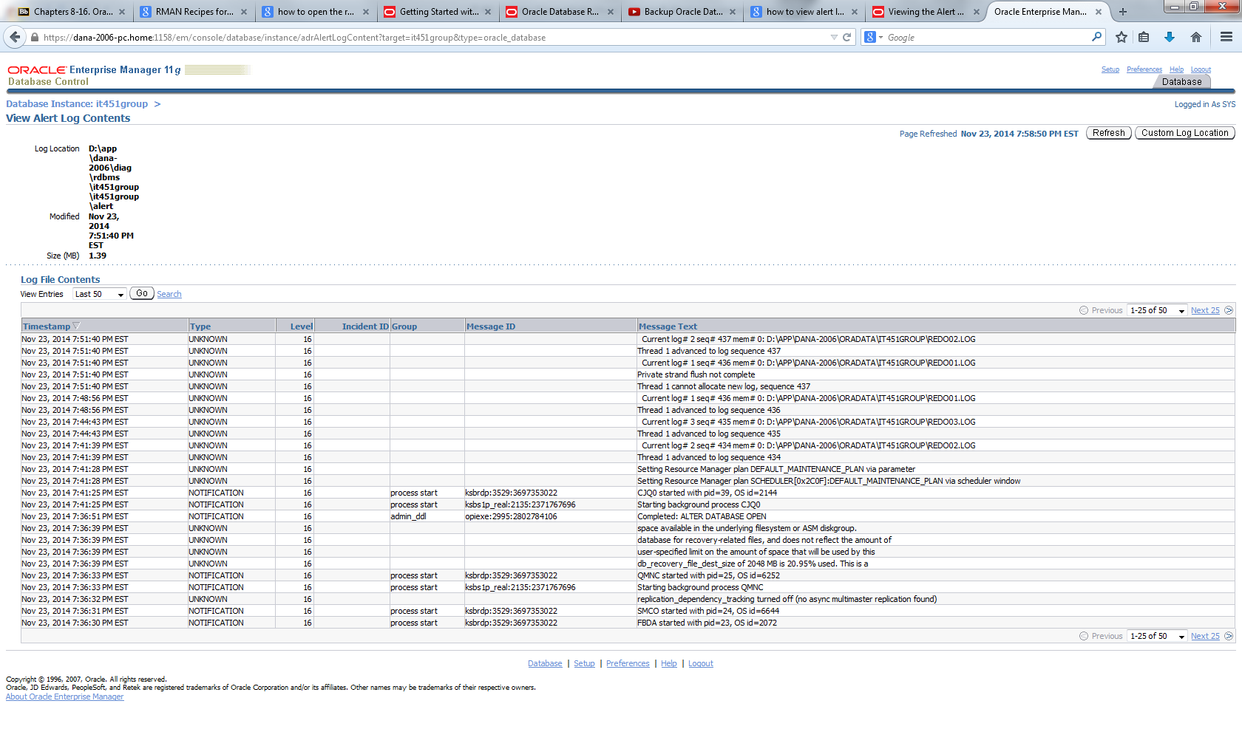
- Use database control to schedule backups

We had to resize the flash recovery area to a larger size because we got the error
ORA - 19804 : cannot reclaim 52428800 bytes disk space from 2147483648 limit.

Alter system set db_recovery_file_dest_size = 30G SCOPE = BOTH;

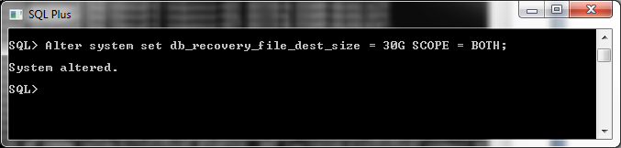

Open EM and go to the availability tab and select schedule backup.
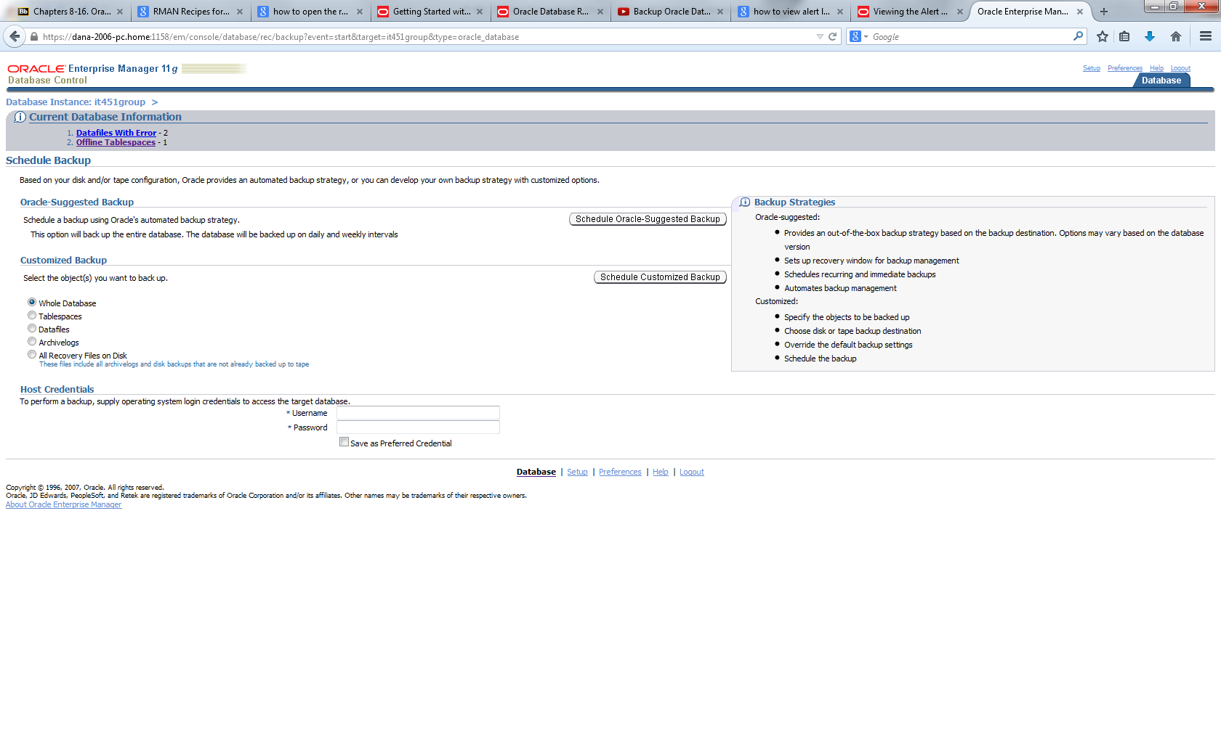

Select the Schedule Customized Backup. Change what you want and then select Next. We left everything as default.

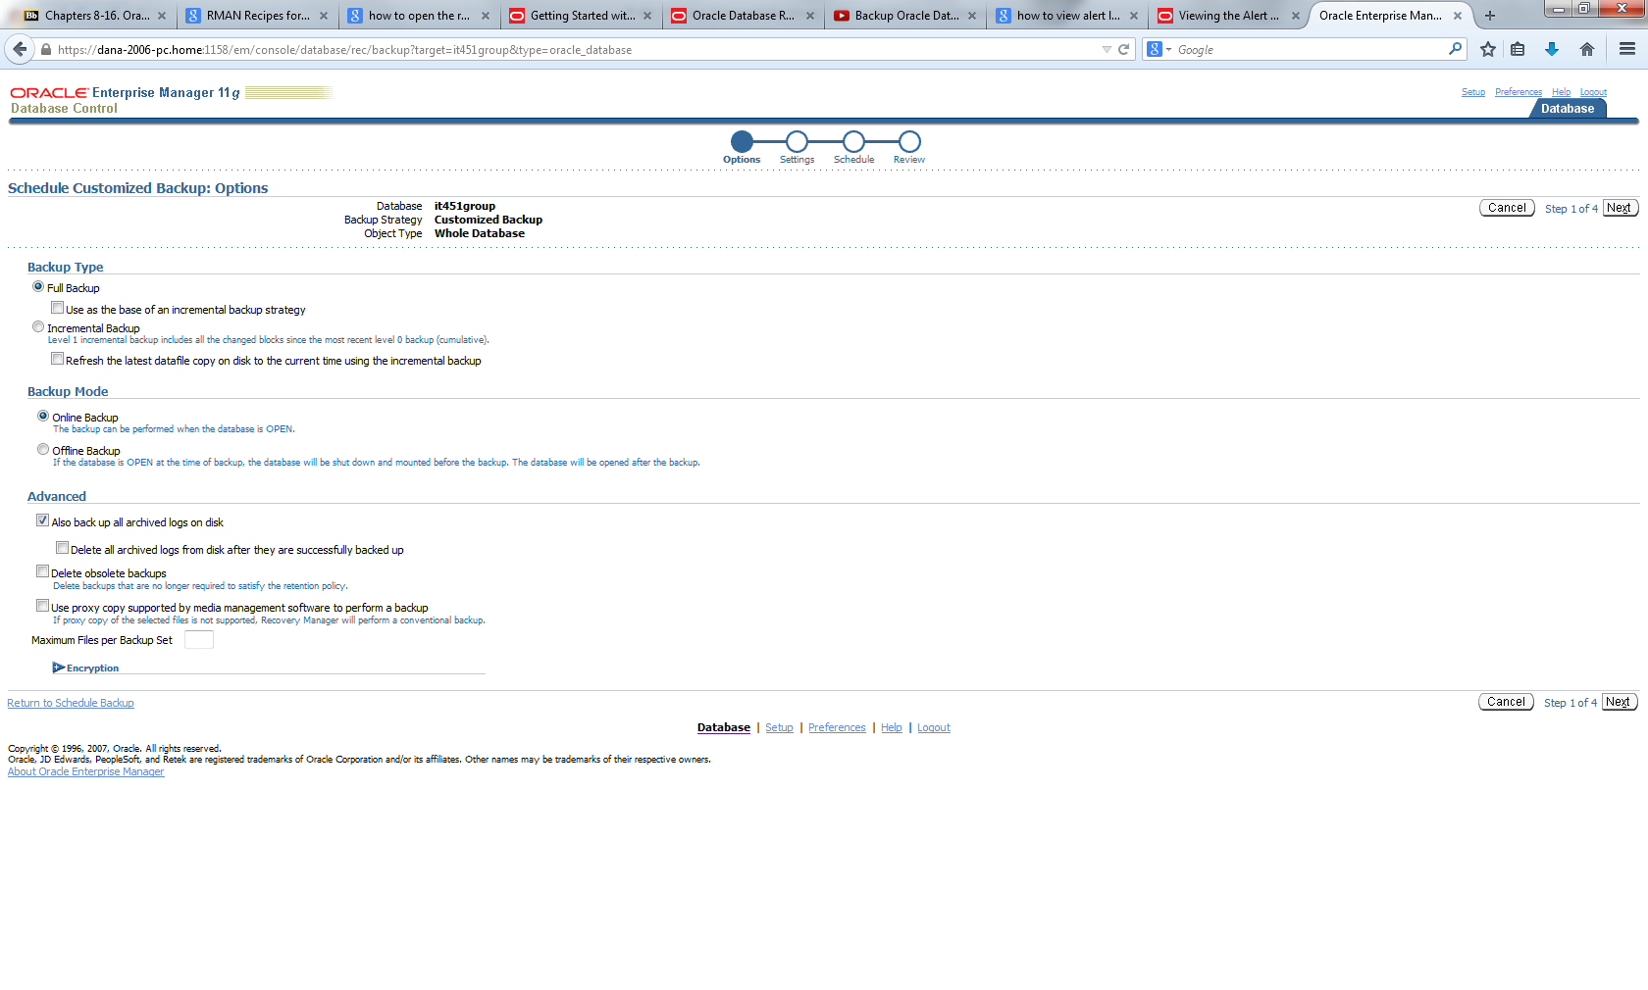

Select what you want to change for the settings then select Next.
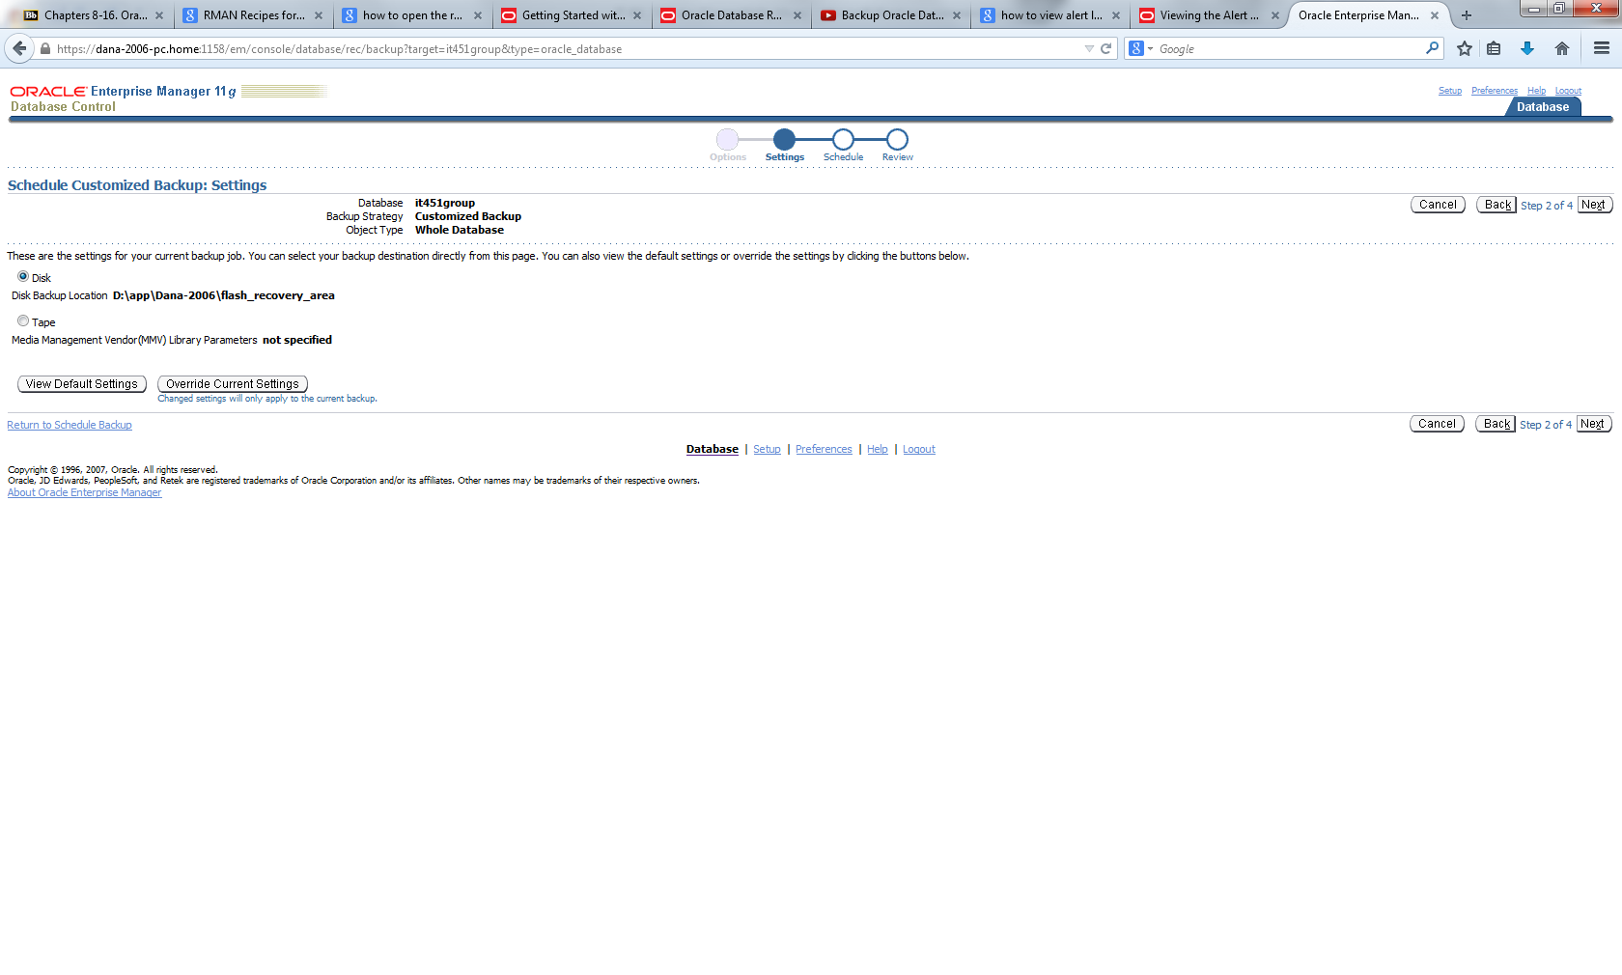

Select what you want to change for the schedule then select Next.
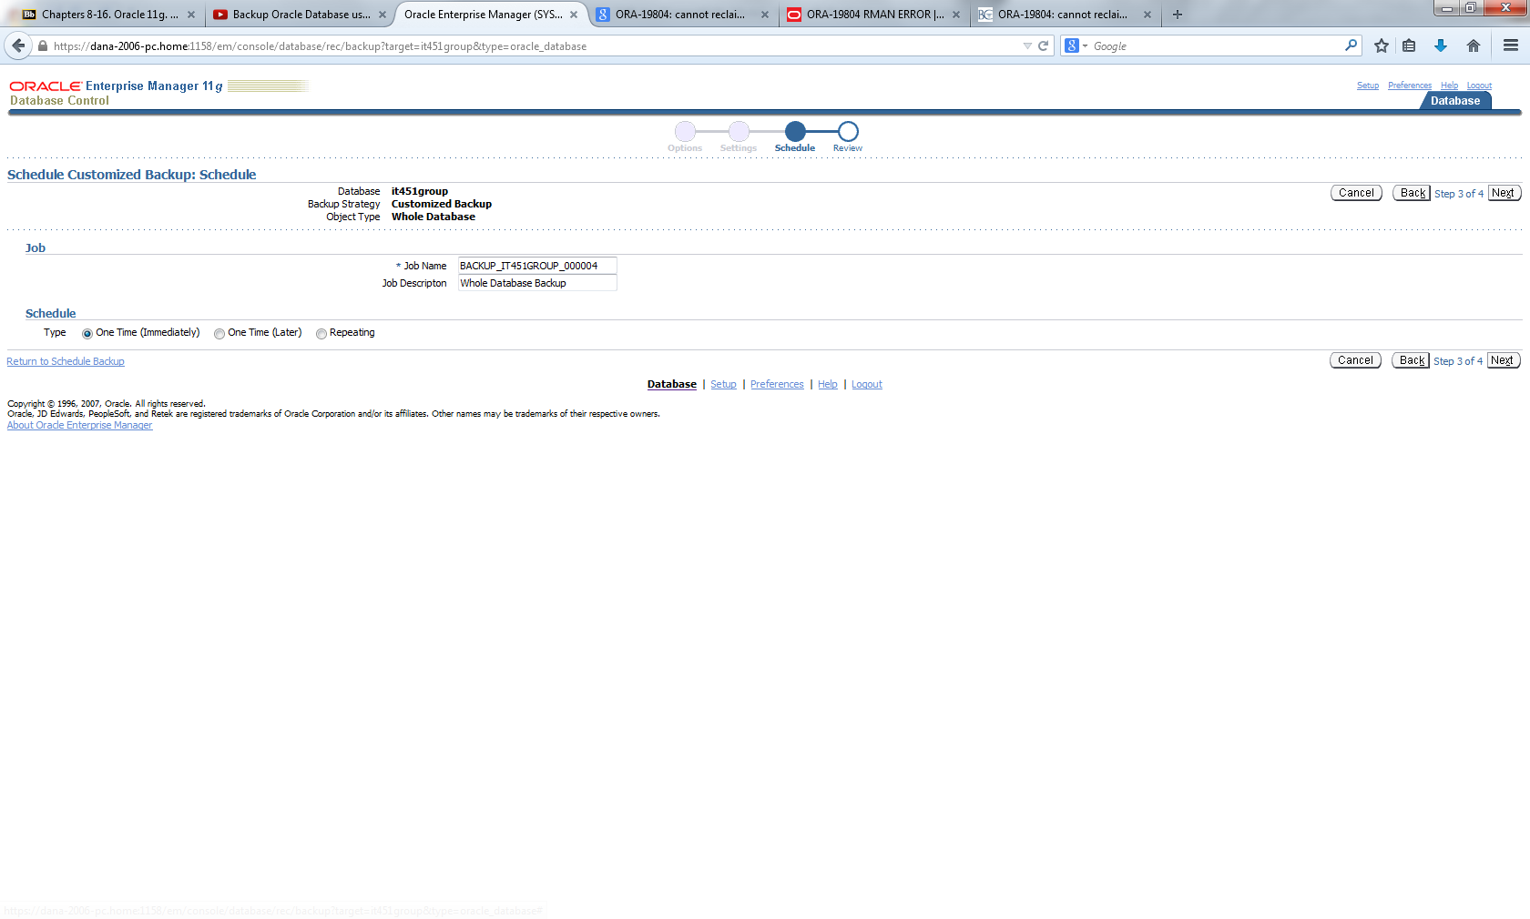

Review the backup details then select Submit Job.
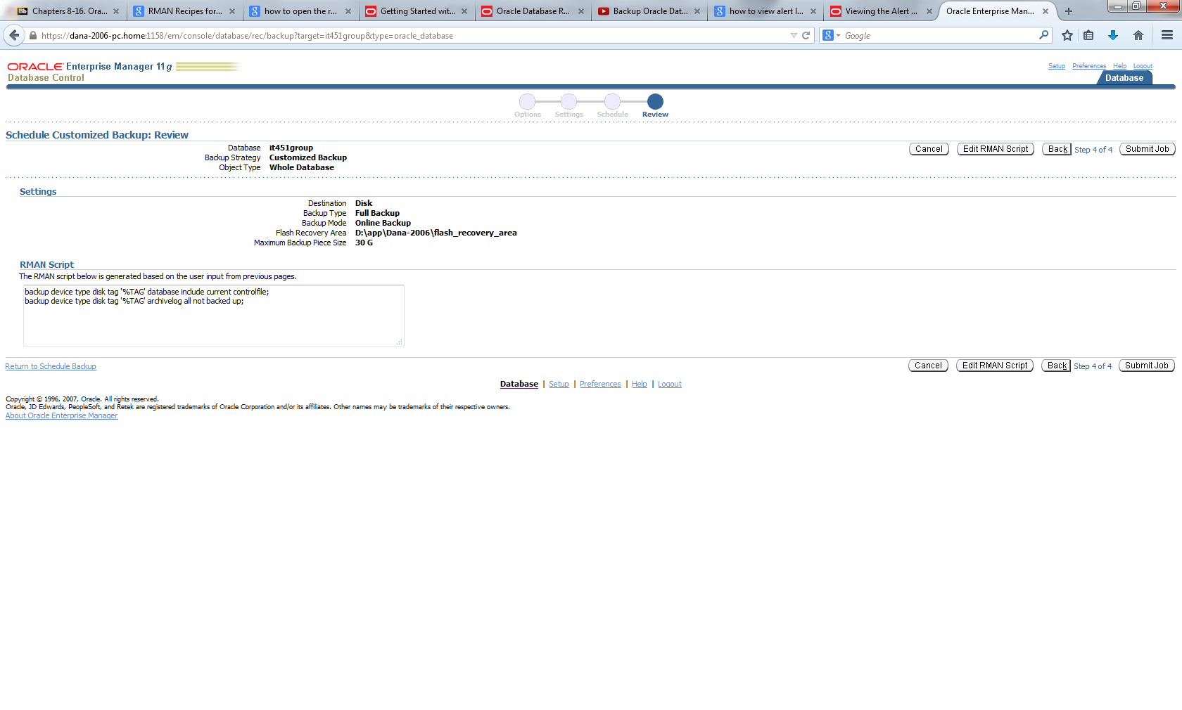

Job successfully set up. Then select View Job to view the process of the backup from pre-backup to backup to post backup.
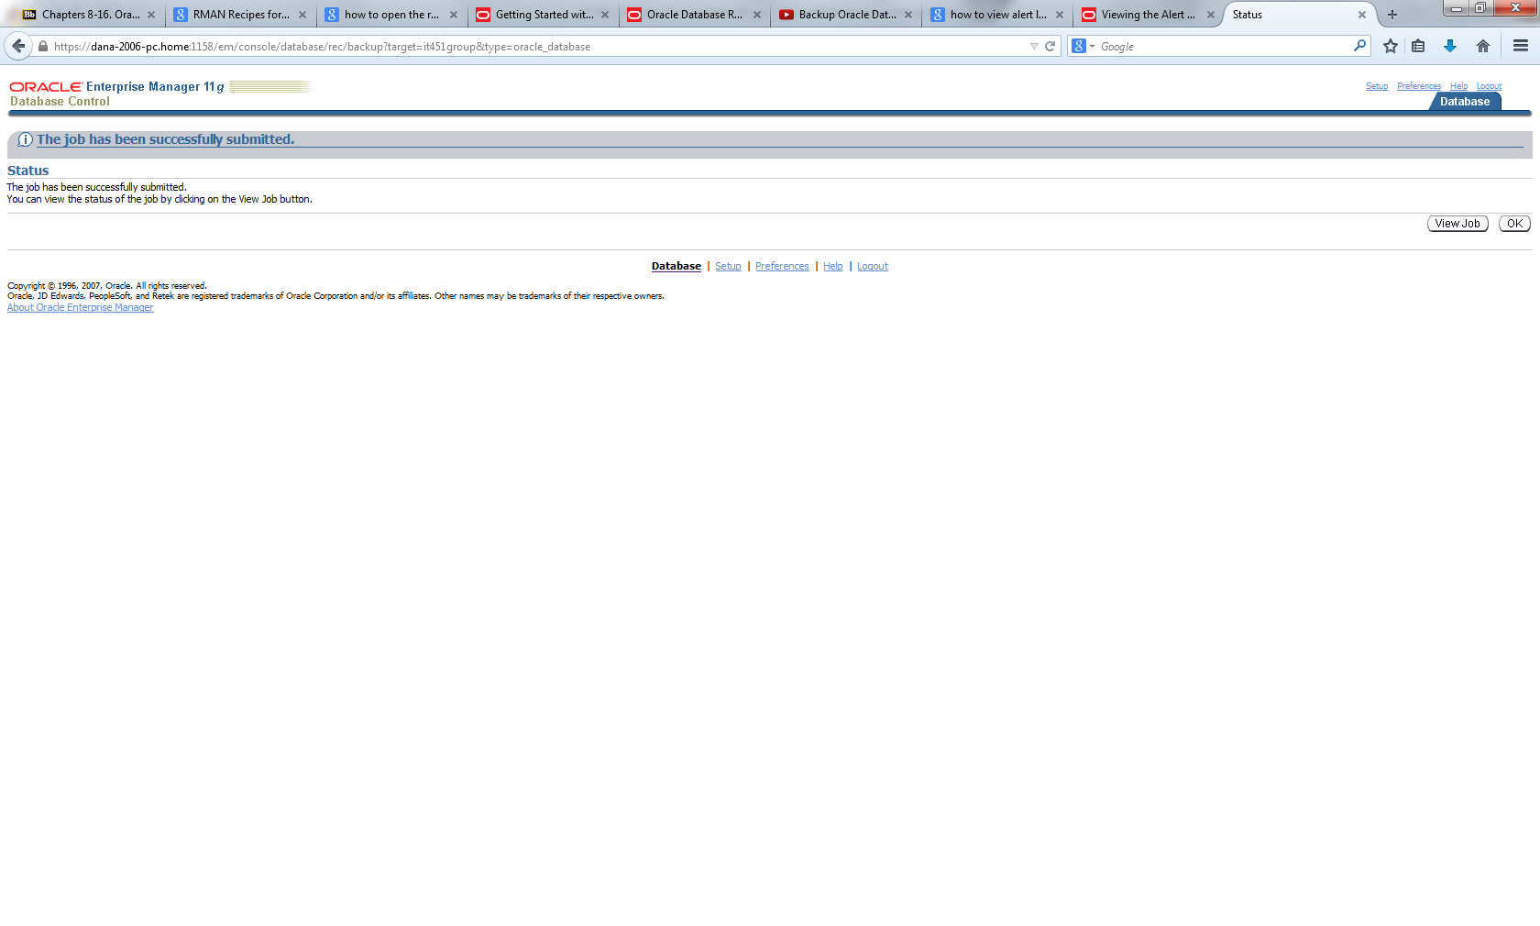
Execution of the backup

Pre-backup, backup, and post backup screenshot
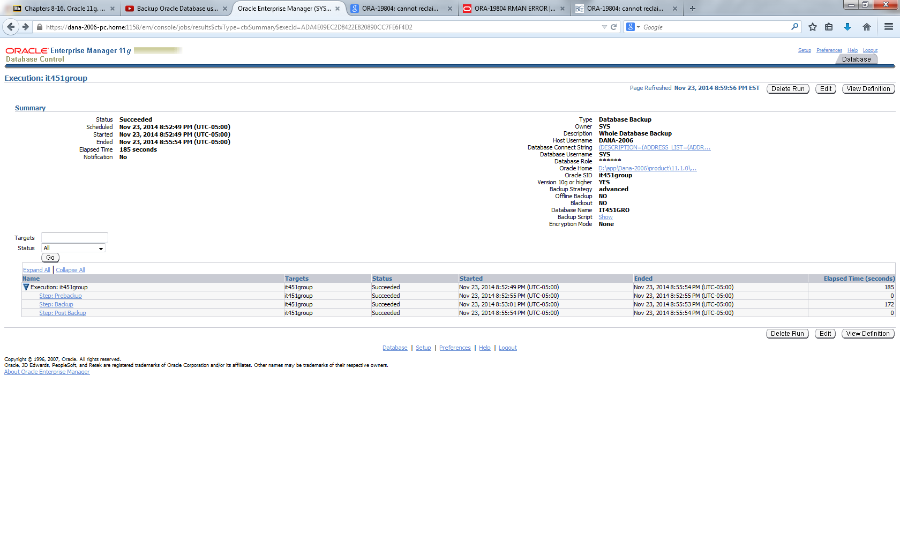

Backup successful screenshot

